

TBase User Manual

修订历史
Copyright Clarigy
Copyright of the document belongs to Beijing TAOS Data Science and Technology Ltd. Any copy is not allowed without the written permission of Beijing TAOS Data Science and Technology Ltd.

版本 | 日期 | 主要作者
0.9.1 | 8/12/2017 | 林胜利，陶建辉 | 初稿
0.9.2 | 8/28/2017 | 林胜利 | 添加GCC版本检查内容
0.9.3 | 9/9/2017 | 陶建辉 | 添加subscriber API
0.9.4 | 10.8/2017 | 关胜亮 | 添加windows客户端及程序接口
0.9.5 | 10.21/2017 | 林胜利 | 修改TBase(引擎)为TBase

Contents

1 Installation 4
2 TBase file and directory structure 5
3 TBase Shell 5
4 Start, stop and uninstall TBase 6
5 TBase SQL 7
6 TBase API 9
6.1 C/C++ synchronous interfaces 9
6.2 C/C++ asynchronous interfaces 10
6.3 Subscriber interfaces 11
6.4 JDBC interfaces 11
7 Windows client and interfaces 14
7.1 Install client 14
7.2 C++ interfaces 15
7.3 ODBC interfaces 15
7.4 JDBC interfaces 16
8 TBase cluster 16
8.1 Basic concepts 16
8.2 Add/Remove management nodes 17
8.3 Add/Remove data nodes 18
9 TBase configurations 18
10 Feedback 19

TBase is a high-efficient, scalable, high-available distributed time-series database, which satisfies the properties of AP in the CAP theorem. TBase makes a lot of optimizations on inserting and querying data, which is far more efficient than normal regular databases. So TBase can meet the high requirements of IOT and other areas on storing and querying a large amount of data.

Installation
TBase supports Linux systems with systemd as the init manager, such as Ubuntu 16.04 and later versions and Centos 7 etc. It is easy to install TBase with TBase installation packages.

- Uncompress the TBase installation package
TBase installation packages are named in the form of tbase-xxxx.tar.gz, in which xxxx contains the information about version, build time and etc. When installing TBase, copy the package to a user readable and writable directory and run the following command:

tar –zxf tbase-xxxx.tar.gz

- Run install.sh script
After uncompressing the software package, two files will show in the uncompressed directory: install.sh and tbase.tar.gz. Run install.sh to install TBase:

bash install.sh

- Test if TBase was installed successfully
After step 2, run command below to test if TBase was installed successfully:

taos -p

Enter the default password taosdata for root user, if a welcome message like below is show, TBase was installed successfully:

Welcome to the TBase shell, server version: 0.9.2, client version: 0.9.2
Copyright © 2017 by TBase Data, Inc. All rights reserved

Tips: For more installation options, please run ./install.sh –h for help.

TBase file and directory structure
After installing TBase successfully, following directories are created:

- Binary directory: /usr/local/bin/tbase
This directory contains following binary files of TBase:
- tbased: Binary file of TBase back ground service and starts automatically at system boot.
- tbase: TBase shell binary file.
- remove.sh: Script uninstalling TBase

- Configuration directory: /etc/tbase
This directory contains the configuration file tbase.cfg, which is used to configure TBase service and shell.

- Storage directory: /var/lib/tbase
Data managed by TBase are stored in this directory. Avoid managing files in this directory in case of systematic issues.

- Log directory: /var/log/tbase
The log information produced by TBase are put here and the information can be configured in the configuration file above. Developers can do troubleshooting with these logs.

TBase Shell
TBase provides a shell interface for users using standard SQL to access the database, such as creating/deleting databases/tables, inserting/querying records etc. root users also can manage user accounts and nodes. For example, add/remove user accounts and monitor the status of each node etc. Below are some examples showing how to use TBase shell:

- Log in as root user and the default password for root user is taosdata.
$ taos –p
Enter password:

- Create database
taos> create database testdb;
Query OK, 1 row(s) are affected (0.001723 s)

- Use database
taos> use testdb;
Database changed.

- Create table
taos> create table meter1(ts timestamp, speed int);
Query OK,1 row(s) are affacted (0.002123 s)

- Insert records
taos> insert into meter1 values(now,100);
Query OK,1 row(s) are affacted (0.001746 s)

- Query records
taos> select * from meter1;
ts | speed |
=================================
17-08-04 09:58:03:907| 100|
Query OK,1 row(s) in set (0.001718 s)

Command line parameters: If TBase shell starts without any parameter (except -p, all parameters are set as default. Users can use taos (without any parameter) to get detailed information about TBase shell parameters. Below are some important parameters needed to mention:
- -u: Assign the username to log in. Default is root.
- -p: Use password to log in and this parameter is mandatory. The default password for user root is taosdata.
- -h: Assign the IP address of the master management node. Default is local IP address.
Tips: Up/Down arrow can be used to search input histories in TBase shell. To change password for users, use alter user command.

Start, stop and uninstall TBase
TBase service is provided by the daemon tbased, which starts automatically by default at system boot after installation. Users can start/stop TBase service with commands below:

$ sudo systemctl start tbased # Start TBase service
$ sudo systemctl stop tbased # Stop TBase service

Users can also disable TBase service from starting at system boot by the command:

$ sudo systemctl disable tbased

To enable TBase service to start at system boot, replace disable with enable in the command above.

To check the status of TBase service, users can use command below in shell:

$ sudo systemctl status tbased

To uninstall TBase from Linux system, run command:

$ sudo rmtaos

Tips: When uninstalling TBase, users can chose to keep or delete the data file.

TBase SQL
For convenience, TBase supports a subset of SQL. Users can run SQL in TBase shell to access the database. Below are some examples:

- CREATE DATABASE db_name REPLICA replica DAYS days KEEP keep;
Create a database named db_name as in SQL but with three extended keywords (red part):
- REPLICA: Assign the number of replications of data, with default being 1—no replica.
- DAYS: Appoint the number of days a database can hold data in. The default value for DAYS is 10 days.
- KEEP: Assign the time that data can be kept in the database. The default value for KEEP is 3650 days (10 years). Data inserted before this time will be removed automatically.

- CREATE TABLE tb_name (name data_type,…);
Create a table as in SQL and the data types supported by TBase include: timestamp, tinyint, smallint, int, bigint, float, double, bool and binary. For the binary type, the length of bytes must be assigned. For example, binary(20) means a string with 20 bytes. At present, binary only supports string inputs and the inputs are converted to lower case unless single quoted. TBase only supports timestamp as the keyword.

- SELECT colume1, colume2, …, columeN FROM table_name WHERE [condition1] AND [condition2] OR …;
Query records and only conditions regarding to timestamp are supported now. For example, to query the data in the past 1 hour:

taos> select * from t1 where ts > now-1h;

- INSERT INTO tb_name VALUES (field_value, …);
Insert a record to table tb_name as in SQL.

- USE db_name;
Use database db_name.

- DROP table table_name;
Delete the table table_name.

- DROP database db_name;
Delete the database db_name, including all the tables in the database.

- CREATE USER user_name PASS ‘password’;
Create a user account and assign the username and password. Make sure that the password is single-quoted or it will be converted to lower case automatically.

- DROP USER user_name;
Remove a user account. Only root user can use this command.

- ALTER USER user_name PASS ‘password’;
Change user’s password. Make sure the password is single-quoted or it will be converted to lower case.

- SHOW USERS;
Show all users.

- SHOW DATABASES;
Show the information of databases.

- SHOW TABLES;
Show the information of tables.

- SHOW DNODES;
Show the information of data nodes.

- SHOW MNODES;
Show the information of management nodes.

- SHOW VGROUPS;
Show the information of all virtual groups.

About timestamps: Timestamps are required when inserting/querying records. The format of timestamp is YEAR-MONTH-DAY H:M:S:MS with resolution of millisecond, 2017-08-12 18:25:58:128 for example. TBase also provides an internal variable now, which indicates current system time. If timestamp is set as 0, current system time is used as well. The timestamp type in TBase supports arithmetic operations, which is useful especially in query conditions. Supported time types include s(second), m(minute), d(day), w(week), n(month) and y(year). For example, to query data between two weeks ago and one week ago, we can do as:

taos> select * from t2 where ts > now-2w and ts <= now-1w;

Tips: The SQL inputs are case-insensitive and are converted to lower case automatically unless single-quoted. So for password, make sure to quote it to prevent being converted to lower case.

TBase API
TBase currently provides two sets of API: C/C++ interface and Java/JDBC interface. ODBC, Restful API and other interfaces such as Hadoop and Spark will be provided latterly.

C/C++ synchronous interfaces
TBase provides a subset of synchronous MySQL API for C/C++ development. For detailed descriptions of those APIs, users can refer to MySQL documents. In order to user the C/C++ synchronous APIs, include the header file taos.h(in /usr/local/include/tbase) in the source code as below:

In linking stage, make sure to link with TBase dynamic library libtaos.so (in /usr/local/lib). For all APIs, the return value of -1 or NULL means failures occur. Below are some detailed descriptions about the APIs:

- taos_connect
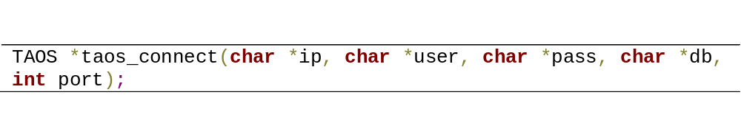This API is used to establish a connection to TBase. Parameters include:
- ip: TBase master management node IP address. If NULL, the IP address configured in tbase.cfg is used.
- user: User name. If NULL, set as root by default
- pass: Password of the user account.
- db: Database to use after connection. If NULL, no database is used.
- port: Port number that TBase master management node serves at.

Failures occur if the return value is NULL. The return pointer should be kept for later use.

- taos_close
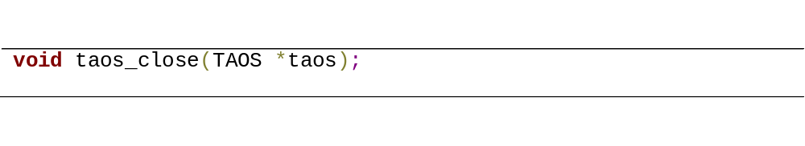This API is used to close the connection with TBase.
- Taos: The return pointer of taos_connect.

- taos_query
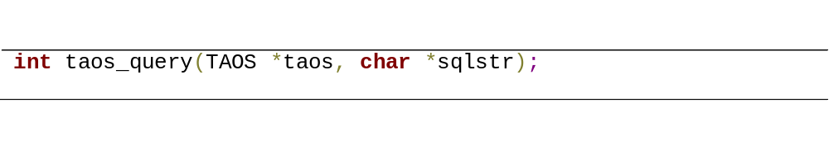This API is to run SQL command including DQL, DML and DDL.
- taos: The return pointer of taos_connect.
- sqlstr: String of SQL command.
Failure occurs if -1 is returned.

- taos_use_result
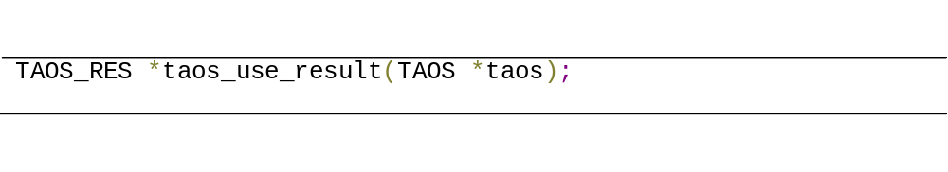This API is to use the query results. The return value of is a pointer of TAOS_RES. Users can use the taos_fetch_row API to fetch the results.
- taos: The return pointer of taos_connect.

- taos_fetch_row
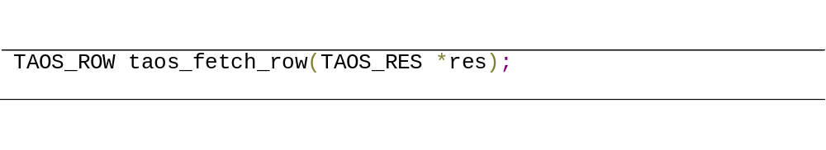To fetch the query results row by row.
- res: The return pointer of taos_use_result.

- taos_free_result
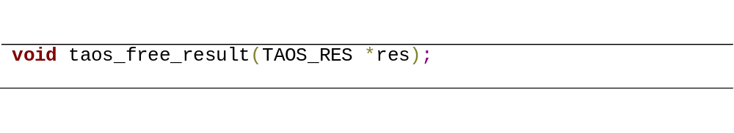Free resources allocated for the query results.
- res: The return value of taos_use_result.

- taos_init
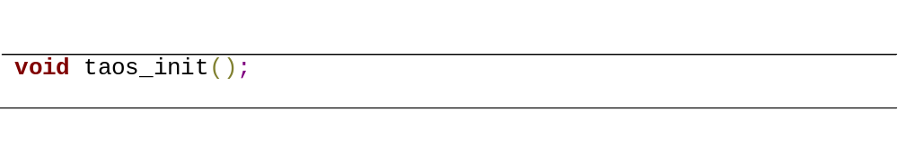This API is for initialization and is called automatically when using taos_connect to connect to TBase. If multiple connections to the database is required in application, multi-thread applications for example, it suggested to call this API before the taos_connect for the reason of security.

- taos_errstr
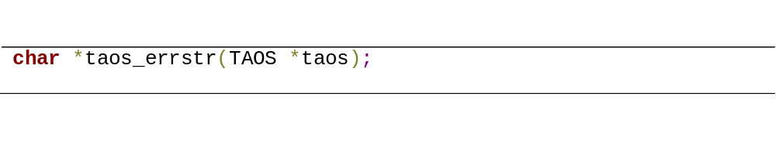Return the error message on failure.
- taos: The return pointer of taos_connect

For more auxiliary APIs, please refer to taos.h.

These APIs are mutually blocked and only return after execution finished. Only one thread can call the APIs at one moment for the same database connection, or security problems may occur. However, for the same application, it is possible to establish connections to different databases without interference.

C/C++ asynchronous interfaces
TBase also provides a set of asynchronous APIs for high-efficiency, which are as 2 to 4 times fast as the synchronous APIs. The unblocked asynchronous APIs only do local checks and return before executions finish. All asynchronous APIs require a callback function in the form of:
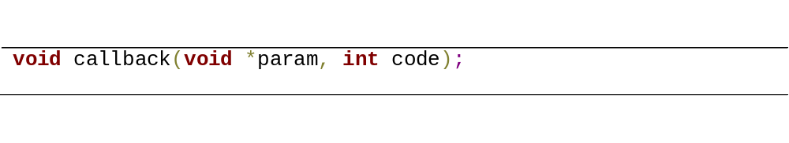
in which, param is provided to system when applications call asynchronous APIs, and code is the return value for a certain API and 0 and -1 for success and failure respectively. Below are details of some important asynchronous APIs.
- taos_open_table
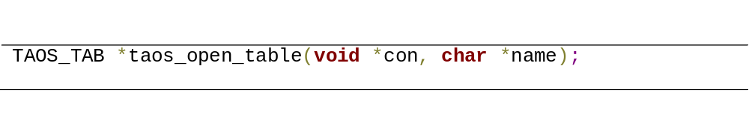Open a table.
- con: The return pointer of taos_connect.
- name: The name of the table to open.

- taos_close_table
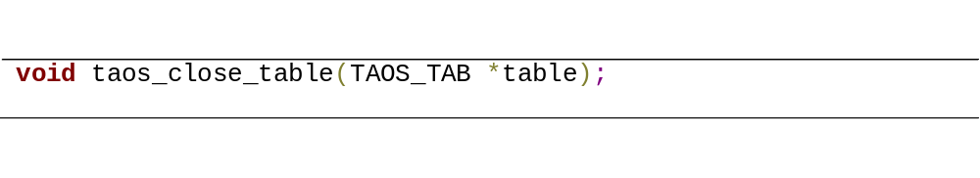Close an opened table.
- table: The return pointer of taos_open_table.

- taos_insert
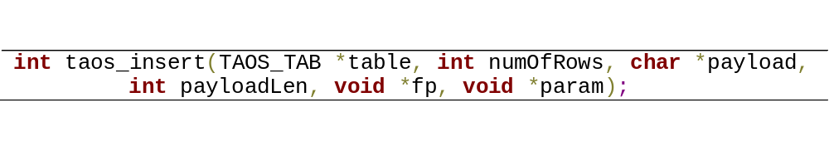This API is used to insert data to a table in byte stream format.
- table: The return pointer of taos_open_table.
- numOfRows: The data stream constructed according to TBase data type definition.
- payloadLen: The payload byte length.
- fp: Pointer to the callback function mentioned above.
- param: Parameter to the callback function.

- taos_select
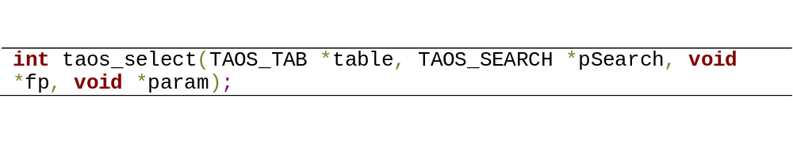Do a query operation.
- table: The return pointer of taos_open_table.
- pSearch: A structure for query command. Detailed information can be found in taos.h.
- fp: Pointer to the callback function mentioned above.
- param: Parameter to the callback function.

- taos_retrieve_async
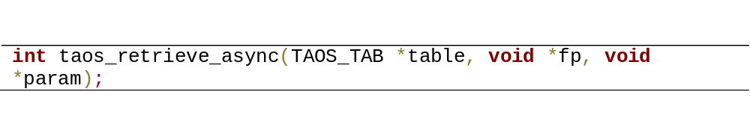This API is to retrieve the query results asynchronously. Definitions of parameters are the same as taos_select.

- taos_free_result_async
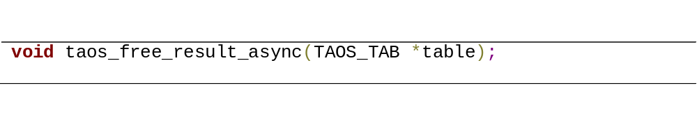This API is used to free resources used by results.

APIs above are unblocked, so a multi-thread application can open multiple tables and do operations at the same time. But it is important to notice that operations on the same table must be serial.

Subscriber Interfaces
TBase also provides a set of APIs for subscription like Kafka, which means that applications can ask for notices when databases is updated.

- taos_subscribe
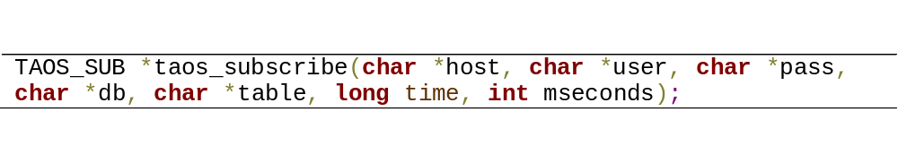This API subscribe a table in TBase.
- host: IP address of the master management node.
- user: User name.
- pass: Password for the user account.
- db: Database name to subscribe.
- table: Table name to subscribe.
- time: Time to start the subscription.
- mseconds: Time interval in the unit of millisecond to check the update of the table.
This API will return NULL on failure. Please keep the return pointer for later use.

- taos_consume
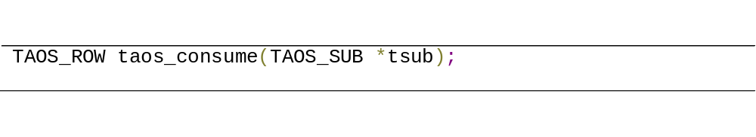This API is used to check the update of database, which should be put in an infinite loop.
- tsub: The return value returned by taos_subscribe.

- taos_unsubscribe
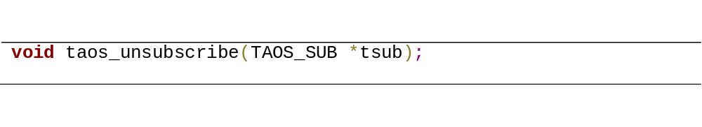This API is used to unsubscribe. Please call this interface at the end of applications in case of memory leak.

JDBC interfaces
Users also can access TBase by JDBC interfaces. Tow files are required when using TBase JDBC interfaces: libtaos.so in /usr/lib and JDBCDriver-1.0.0.dist.jar in /usr/local/bin/tbase/connector. When using JDBC to access TBase, make sure the JDBC driver file is in your current CLASS_PATH.

Like C driver, TBase also provides synchronous and asynchronous JDBC drive APIs. For asynchronous APIs, please refer other manuals for information. For synchronous APIs, they follow the JDBC standard. So users can use them like other standard JDBC driver APIs. Because of the difference between time-series database and RDBMS, only a subset of APIs is implemented. For example, with JDBC APIDs provided by TBase, users can create table (CREATE TABLE …), insert table (INSERT INTO …) and query data (SELECT * FROM TABLE …) etc. However, since data stored in time-series databases, in general, are generated from terminal devices such as sensors, they are invariant. So TBase does not provide APIs to update (UPDATE TABLE …) or delete (DELETE FROM …) data in the database. Below are some example codes for developers:

- Query data example
public class TSDBJDBCDriverTest {
public static void main(String[] args) {
Connection conn = null;
Statement stmt = null;
ResultSet resSet = null;
try {
Class.forName(TSDB_DRIVER);
Conn= (Connection) DriverManager.getConnection(TSDB_URL);
stmt = (Statement) conn.createStatement();
resSet = stmt.executeQuery("SELECT * FROM Device");
ResultSetMetaData metaData = resSet.getMetaData();
int rowIndex = 0;
while (resSet.next()) {
StringBuffer strBuff = new StringBuffer();
for (int i = 0; i < metaData.getColumnCount(); i++) {
strBuff.append(metaData.getColumnName(i) + "="
+TSDBResultSetUtils.getValueFromResultSet(resSet, i, metaData));
}
System.out.println(strBuff);
rowIndex++;
}
} catch (ClassNotFoundException e) {
// TODO Auto-generated catch block
e.printStackTrace();
} catch (SQLException e) {
// TODO Auto-generated catch block
e.printStackTrace();
} catch (Exception e) {
// TODO Auto-generated catch block
e.printStackTrace();
} finally {
try {
if (resSet != null)
resSet.close();
if (stmt != null)
stmt.close();
if (conn != null)
conn.close();
} catch (SQLException e) {
// TODO Auto-generated catch block
e.printStackTrace();
}
}
}

static final String TSDB_DRIVER = "com.taosdata.jdbc.TSDBDriver";
static final String TSDB_URL = "jdbc:TSDB://127.0.0.1:0/tsdb?user=root&password=taosdata";
}

- Create table example
public class TSDBJDBCDriverTest {
public static void main(String[] args) {
Connection conn = null;
Statement stmt = null;
ResultSet resSet = null;
try {
Class.forName(TSDB_DRIVER);
conn= (Connection) DriverManager.getConnection(TSDB_URL);
stmt = (Statement) conn.createStatement();
int updateCount = stmt.executeUpdate(
"create table meter(ts timestamp, temperature tinyint)");
if (updateCount == 0) { //Any non-0 values mean failure.
// succeed to create table
}
else {
// fail to create table
}
} catch (ClassNotFoundException e) {
e.printStackTrace();
} catch (SQLException e) {
e.printStackTrace();
} catch (Exception e) {
e.printStackTrace();
} finally {
try {
if (resSet != null)
resSet.close();
if (stmt != null)
stmt.close();
if (conn != null)
conn.close();
} catch (SQLException e) {
e.printStackTrace();
}
}
}

static final String TSDB_DRIVER = "com.taosdata.jdbc.TSDBDriver";
static final String TSDB_URL = "jdbc:TSDB://127.0.0.1:0/tsdb?user=root&password=taosdata";
}

Windows client and interfaces

Install client
TBase provides 32-bit and 64-bit clients for Windows system. To install TBase client on Windows, it is only required to Uncompress the TBase installation package in any user readable and writable directory. The directory structure of the client is as follows:
- Shell binary files: root_dir/tbase.exe
- Configuration files: root_dir/cfg/tbase.cfg
- ODBC Driver directory: root_dir/odbc
- JDBC Driver directory: root_dir/jdbc
- Windows SDK: root_dir/client
Users can run cmd from Windows start menu and launch TBase shell by running tbase.exe.

C++ interfaces
TBase provides the same C++ APIs on Windows as on Linux. Applications should include the header file taos.h and link with taos.lib. When run applications, put taos.dll in the directory of binary file. Please refer to 6.1, 6.2 and 6.3 for detailed information about TBase C++ APIs.

ODBC Interfaces
Applications can use ODBC interfaces to access TBase with the library files: taosodbc.dll and taosodbc.lib. Users can use two methods below to access TBase with ODBC interfaces:

- Resister to ODBC manager
- Make sure the Window is on Windows 7 or later.
- Change the dll path in directory reg as the path of taosodbc.dll after uncompression. Run reg.
- Run ODBC manager and add new data source. IP address, user name and password are required.
- Test ODBC. Add a data source named demo and check if odbcTest.ext run normally.

- Link libraries to projects directly
- Add dependence on taosodbc.dll and taosodbc.lib in projects.
- Remove the dependence of odbc32.dll on odbccp32.lib.
- Put taosodbc.dll in any executable directory.

Because of different requirements between time-series databases and RDBMS, we only provide a subset of interfaces in ODBC driver standard. The interfaces include:
  - SQLAllocHandle
  - SQLFreeHandle
  - SQLAllocStmt
  - SQLFreeStmt
  - SQLAllocEnv
  - SQLFreeEnv
  - SQLAllocConnect
  - SQLFreeConnect
  - SQLConnect
  - SQLDisconnect
  - SQLDriverConnect
  - SQLError
  - SQLPrepare
  - SQLExecute
  - SQLNumResultCols
  - SQLDescribeCol
  - SQLBindCol
  - SQLExecDirect
  - SQLFetch
  - SQLGetData

JDBC interfaces
On Windows, applications can also access TBase by JDBC interfaces according to the following steps:
- Put JDBC driver package JDBCDriver-1.0.0-dist.jar in current CLASS_PATH.
- Put taos.dll in the directory of system32.
More details about JDBC APIs can be found in 6.4.

TBase cluster
TBase is a distributed database with properties of horizontal scalable and high reliability. Any one or several physical machines’ crash cannot affect the service. Below are descriptions about manipulating TBase cluster.
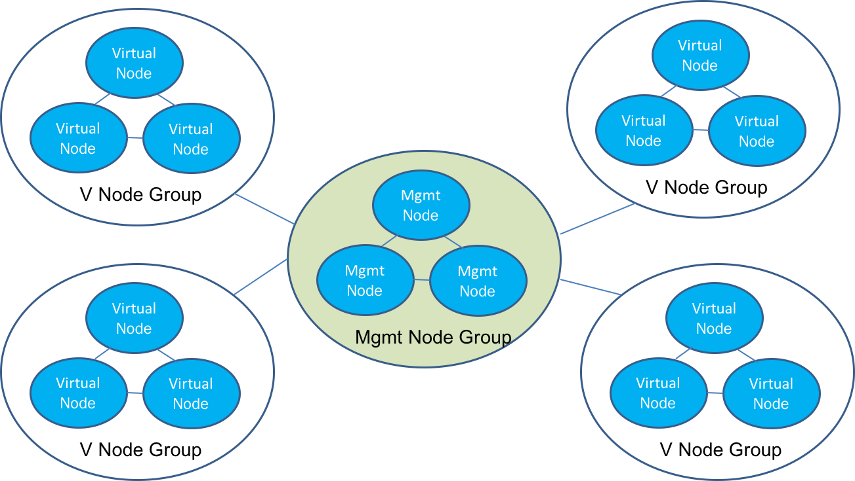

Basic concepts
Physical node: Any physical machine in the cluster is a physical node in TBase. A physical node can act as a management node (MNode) or data node (DNode) or both.

Data node (DNode): Data node is a physical node storing time-series data. Operations like table insertion and query all run on DNodes. On a single DNode, multiple virtual data nodes (VNode) can be created according to available hardware resources on that machine. Virtual nodes on different physical nodes can make up of a virtual node group (VGroup) and VNodes in the same VGroup synchronize automatically with the method of P2P, which provides high reliability. The number of VNodes in a VGroup can be configured as between 1 to 5 with the keyword replica in the configuration file. The default value of replica is 1, which means no backup.

Management node (MNode)：MNodes are physical nodes monitoring the status of DNodes, managing load balance and meta data about user accounts, databases and tables. Applications should access MNode first to get the position of tables before visiting them. With Master-Slave mechanism, TBase allows as many as 5 MNodes to form a management cluster for the sake of high reliability on meta data. All meta data are written by the master MNode but read from any Mnode. When inserting meta data from master MNode, only after all MNodes synchronize will the value be available to query. If the master MNode crashes, one of the slave MNOdes is selected immediately as the new master MNode.

Master IP: The whole cluster consists of a lot of physical machines. Applications only need the master MNode public IP address to get service from TBase cluster. When a data node connects to the master MNode, it will be reassigned to other slave MNodes according to the load balance algorithm. Also, when data are inserted in TBase, it will also be reassigned to proper DNode according to load balance strategy.

Add/Remove management nodes
When tbased starts on a physical machine, that machine becomes a separate TBase node. tbased will read the master MNode IP address from the global configuration file tbase.cfg. If no master MNode IP assress is set in tbase.cfg, it will be set as localhost. If the master MNode IP address is not the same as local machine IP, the physical node will try to send requests to the master MNode to join the cluster.

- Add management nodes
Log in TBase shell as root (run taos –p in command line) and run:

taos> create mnode ip_addr;

in which, ip_addr is the IP address of the node you want to add in the cluster. Users can check if the management node was added successfully by command below:

taos> show mnodes;

- Remove management nodes
Log in TBase shell as root (run taos –p in command line) and run:

taos> drop mnode ip_addr;

in which, ip_addr is the IP address of the node you want to drop from the cluster. Users can check if the management node was removed successfully by command below:

taos> show mnodes;

If no less than two management nodes start and connect successfully, they will synchronize automatically without backup manually.

Add/Remove data nodes
When tbased starts on a physical machine, that machine becomes a DNode of TBase and creates multiple VNodes according to available resources and configurations. The DNode will send requests to the master MNode asking for joining the cluster.

- Add data nodes
Log in TBase shell as root (run taos –p in command line) and run:

taos> create dnode ip_addr;

in which, ip_addr is the IP address of the data node you want to add in the cluster. Users can check if the data node was added successfully by command below:

taos> show dnodes;

- Remove data nodes
Log in TBase shell as root (run taos –p in command line) and run:

taos> drop dnode ip_addr;

in which, ip_addr is the IP address of the data node you want to drop from the cluster. Users can check if the data node was removed successfully by command below:

taos> show dnodes;

For convenience, the management node will add local machine as a virtual node automatically if the requests from local host are received. It can be removed manually.

TBase configuration
TBase service is provided by the daemon of tbased. This daemon provides both management service and data service. This daemon is configured by tbase.cfg in /etc/tbase. For detailed configuration options, users can refer to tbase.cfg. Below are simple descriptions on come options:

- About ports: The default TCP/UDP ports used by TBase, including ports between different nodes and ports between applications and nodes are in the range of 6100—6200, but can be configured in tbase.cfg.
- Number of virtual node on a physical node: The parameter tsNumOfVnodes in file tbase.cfg assigns the number of virtual nodes will be created. This number is restricted by the available hardware resources for TBase. More hardware resources means larger available virtual nodes can be configured. It is recommended to set this parameter no less than 4.

Feedback
If you encounter any problem and need TBase team’s help, please follow the steps below:
- Compress and pack /var/log/tbase and /etc/tbase.
- Write a description about the problem, including the steps to reproduce it (if it can be reproduced) and the time when the problem occurred.
- Send the message and the compressed file above to support@taosdata.com.

If the problem can be reproduced, you can provide us with more detailed information by running commands below:

alter dnode ip_addr debugflag 135;
alter dnode ip_addr taosdebugflag 135;
alter mnode ip_addr debugflag 135;
alter mnode ip_addr taosdebugflag 135;
alter local debugflag 135;
alter local taosdebugflag 135;

in which, ip_addr is the master management node IP address. Then repeat steps above. After reporting the problem to TBase team, run the same commands above but replace 135 as 131 to recover the original setup, or a lot of log information will be produced and impact the database performance.

